Requirement

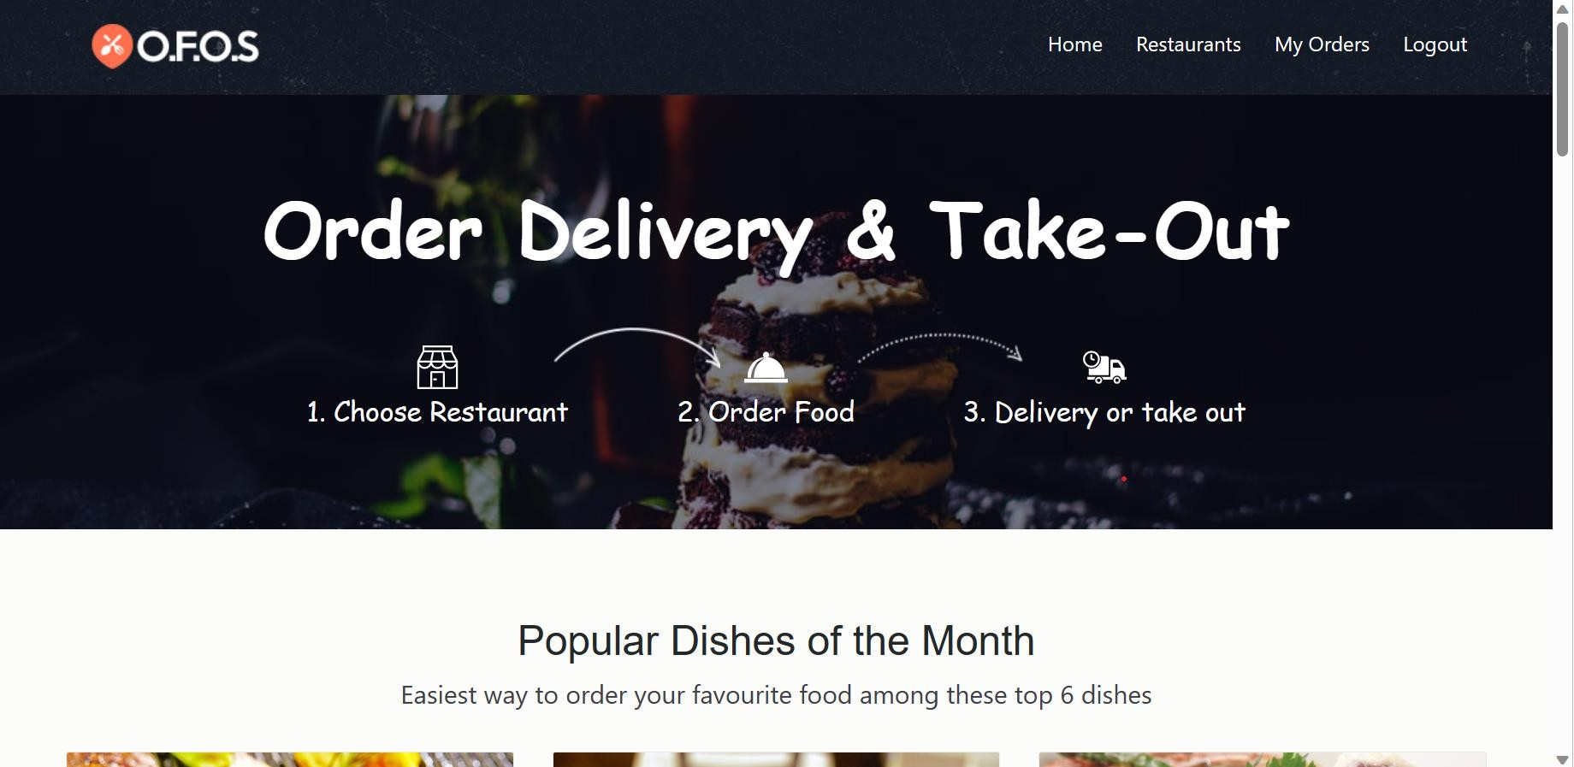

1. **Home Module**
   1. **‘O.F.O.S’ logo** should be present on the top left corner of the page.
   2. **‘Home’ link** should be present on the top right corner of the page.
   3. **‘Restaurants’ link** should be present next to ‘Home’ link.
   4. **‘My orders’ link** should be present next to ‘Restaurants’ link.
   5. **‘Logout’ link** should be present next to ‘My orders’ link.
   6. **‘Order Delivery & Take-Out’ Label** should be present in the middle of the page under the above links.
   7. **‘1. Choose Restaurant’ label** should be present with related image below the above Label.
   8. **‘2. Order Food’ label** should be present with related image next to **‘1. Choose Restaurant’ label.**
   9. **‘3. Delivery or take out’ label** should be present with related image next to **‘2. Order Food’ label**.

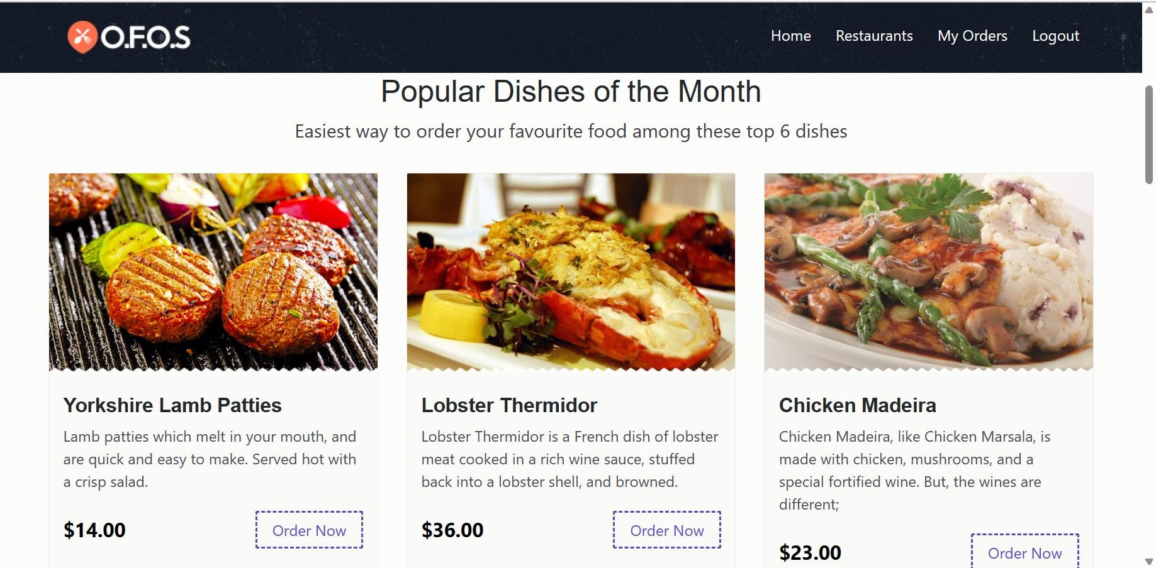

* 1. When the user scrolls down the page **‘Popular Dishes of the Month’** Title should be present with **‘Easiest way to order your favorite food among these top 6 dishes’** should be present.
  2. **‘Yorkshire Lamb Patties’** text with food image, description, price in dollars ($) and **‘Order Now’ button**.
  3. **‘Lobster Thermidor’ label** with food image, description, price in dollars ($) and **‘Order Now’ button**.
  4. **‘Chicken Madeira’ label** with food image, description, price in dollars ($) and **‘Order Now’ button**.

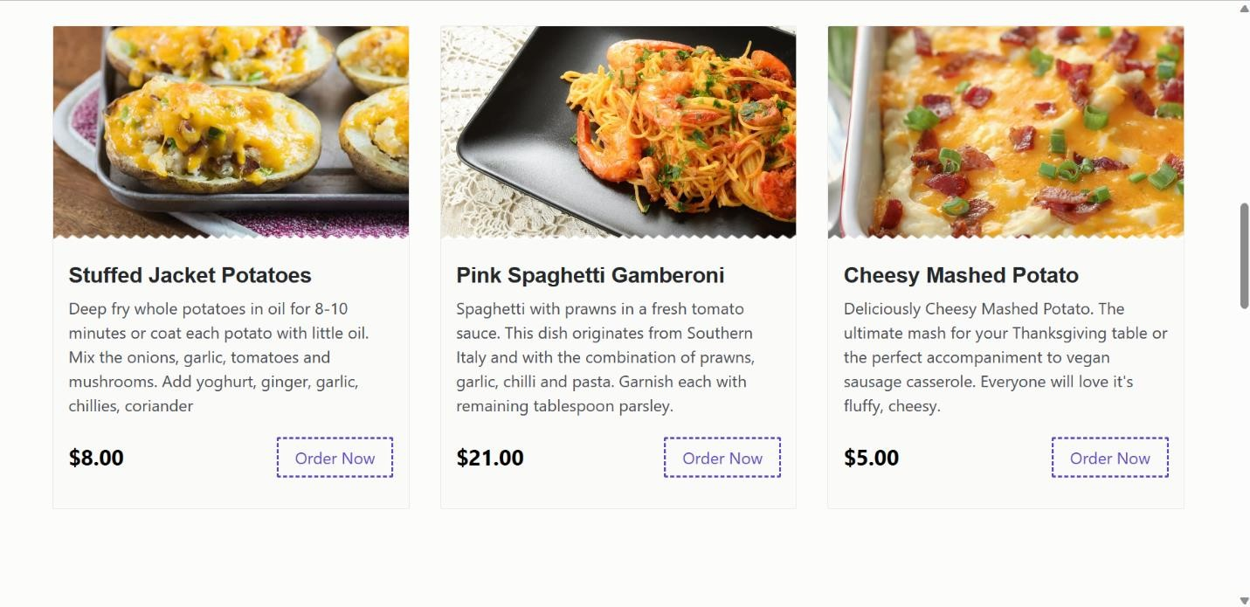

* 1. **‘Stuffed Jacket Potatoes’ label** with food image, description, price in dollars ($) and **‘Order Now’ button.**
  2. **‘Pink Spaghetti Gamberoni’ label** with food image, description, price in dollars ($) and **‘Order Now’ button.**
  3. **‘Cheesy Mashed potato’ label** with food image, description, price in dollars ($) and **‘Order Now’ button.**

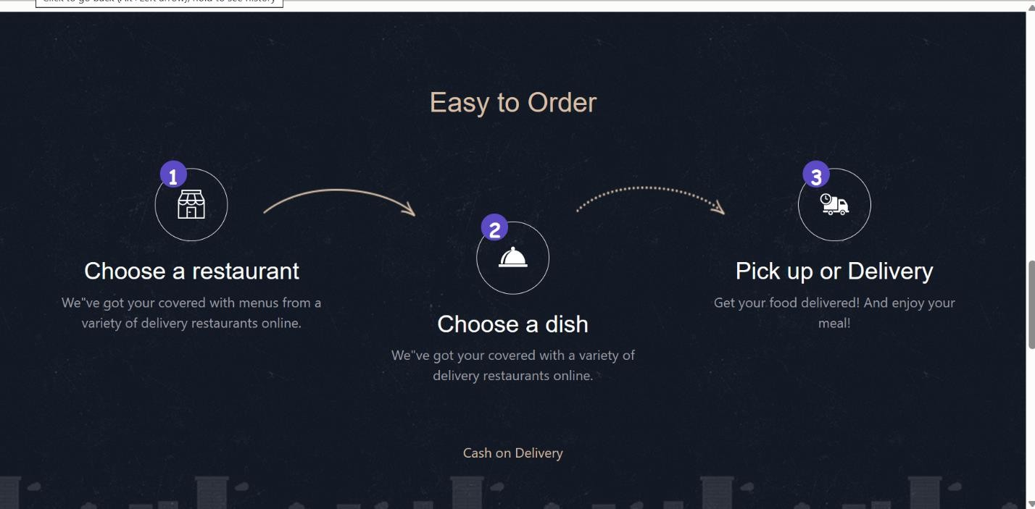

* 1. When the user scrolls down he should be able to see **‘Easy to Order’ text** should be present in the middle of the image, below that **‘Choose a restaurant’ text** with related image and tagline stating ‘We’ve got your covered with menus from a variety of delivery

restaurants online’., next to it ‘Choose a Dish’ label with related image and tagline stating ‘We’ve got your covered with a variety of delivery restaurants online’ and next to it ‘Pick up or Delivery’ label with related image and tagline stating ‘Get your food delivered! And enjoy your meal!’ text should be present. ‘Cash on Delivery’ label should be present below the image in the middle.

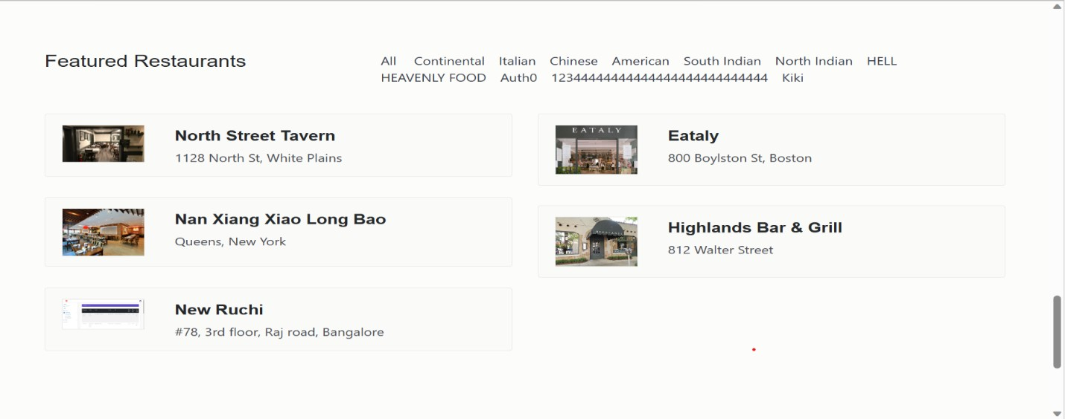

* 1. When the user scrolls down on the top left corner ‘Featured Restaurants’ Label should be present.
  2. On the top right corner ‘All’ link should be present.
  3. ‘Continental’ link should be present next to ‘All’ link.
  4. ‘Italian’ link should be present next to ‘Continental’ link.
  5. ‘Chinese’ link should be present next to ‘Italian’ link.
  6. ‘American’ link should be present next to ‘Chinese’ link.
  7. ‘South Indian’ link should be present next to ‘American’ link.
  8. ‘North Indian’ link should be present next to ‘South Indian’ link.
  9. ‘HELL’ link should be present next to ‘North Indian’ link.
  10. ‘HEAVENLY FOOD’ link should be present next to ‘HELL’ link.
  11. ‘Auth0’ link should be present next to ‘HEAVENLY FOOD’ link. 1.29 ‘1234444444444444444444444444’ link should be present next to

‘Auth0’ link.

* 1. ‘Kiki’ link should be present next to

‘1234444444444444444444444444’ link.

* 1. ‘North Street Tavern’ tab should be present with address mentioned below along with the image.
  2. ‘Nan Xiang Xiao Long Boa’ tab should be present below ‘North

Street Tavern’ tab with address mentioned below along with the image.

* 1. ‘New Ruchi’ tab should be present below ‘Nan Xiang Xiao Long Bao’ tab with address mentioned below along with the image.
  2. ‘Eataly’ tab should be present beside ‘North Street Tavern’ tab with address mentioned below along with the image.
  3. ‘Highlands Bar & Grill’ tab should be present beside ‘Nan Xiang Xiao Long Bao’ tab with address mentioned below along with the image.

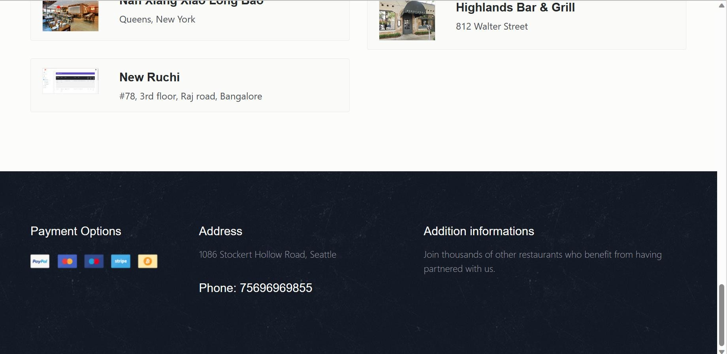

* 1. When user scrolls down, on the left corner ‘Payment options’ label with PayPal, MasterCard, visa, stripe, bitcoin logo should be present below the text.
  2. ‘Address’ label should be present with the tagline ‘1086 Stockert Hollow Road, Seattle’ and ‘Phone:75696969855’ text should be present below the tagline.
  3. ‘Addition informations’ label should be present beside ‘Address’ label and with a tagline ‘Join thousands of other restaurants who benefit from having partnered with us.’

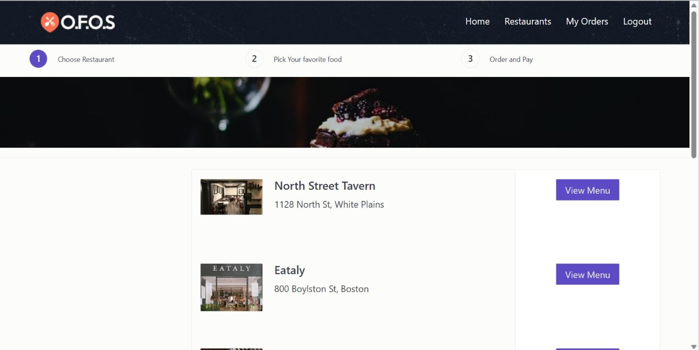

# Restaurants Module

* 1. ‘O.F.O.S’ logo should be present on the top left corner of the page.
  2. ‘Home’ link should be present on the top right corner of the page.
  3. ‘Restaurants’ link should be present next to ‘Home’ link.
  4. ‘My orders’ link should be present next to ‘Restaurants’ link.
  5. ‘Logout’ link should be present next to ‘My orders’ link.
  6. On the left corner of the page below the logo ‘1. Choose Restaurant’ link should be present.
  7. ‘2. Pick Your favourite food’ link should be present in the middle of the page and next to ‘1. Choose Restaurant’ link.
  8. ‘3. Order and Pay’ link should be present on the right corner of the page next to ‘2. Pick Your favourite food’ link.
  9. ‘North Street Tavern’ label with tagline stating ‘1128 North St, White Plains’ with related image.
  10. ‘View Menu’ button should be present beside ‘North Street Tavern’ text.
  11. ‘Eataly’ label with a tagline stating ‘800 Boylston St, Boston’ with related image.
  12. ‘View Menu’ button should be present beside ‘North Street Tavern’ text.

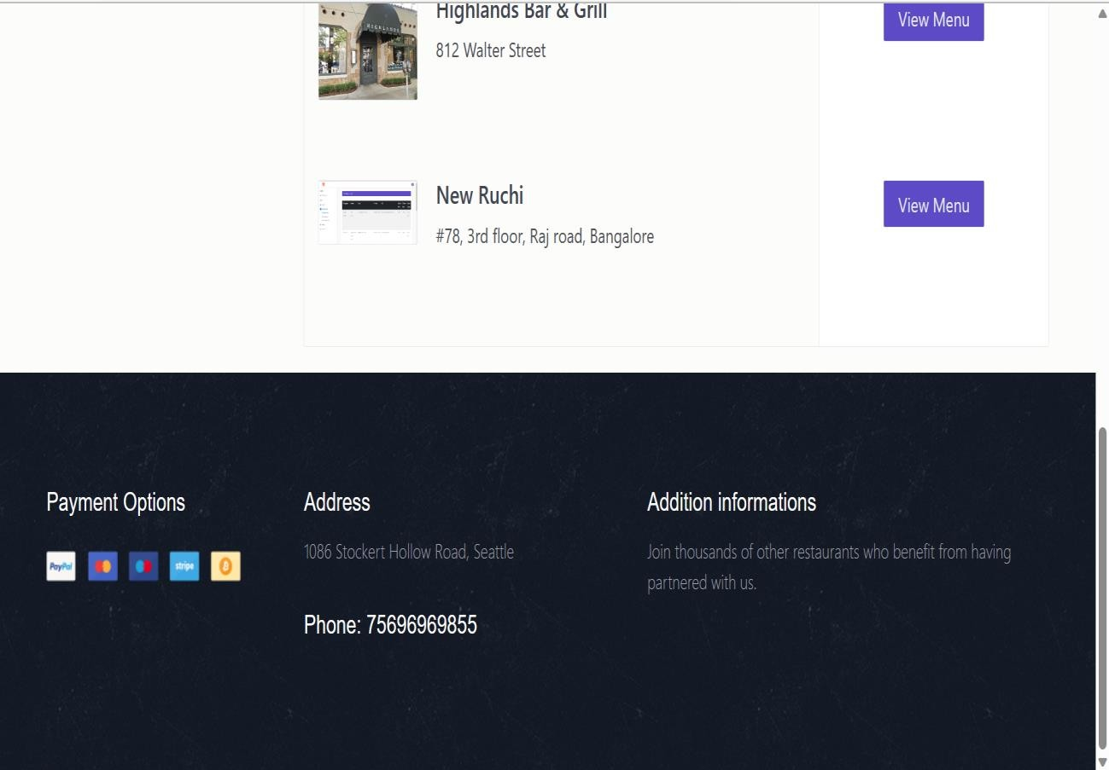

* 1. **‘Highlands Bar & Grill’ label** with tagline stating ‘812 Walter Street’ with related image.
  2. ‘View Menu’ button should be present beside ‘Highlands Bar & Grill’ text.
  3. ‘New Ruchi’ label with tagline stating ‘#78, 3rd floor, Raj road, Bangalore’ with related image should be present.
  4. ‘View Menu’ button should be present beside ‘New Ruchi’ label.
  5. When user scrolls down, on the left corner ‘Payment options’ label with paypal, MasterCard, visa, stripe, bitcoin logo should be present below the text.
  6. ‘Address’ label should be present with the tagline ‘1086 Stockert Hollow Road, Seattle’ and ‘Phone:75696969855’ text should be present below the tagline.
  7. ‘Addition informations’ label should be present beside ‘Address’ label and with a tagline ‘Join thousands of other restaurants who benefit from having partnered with us.

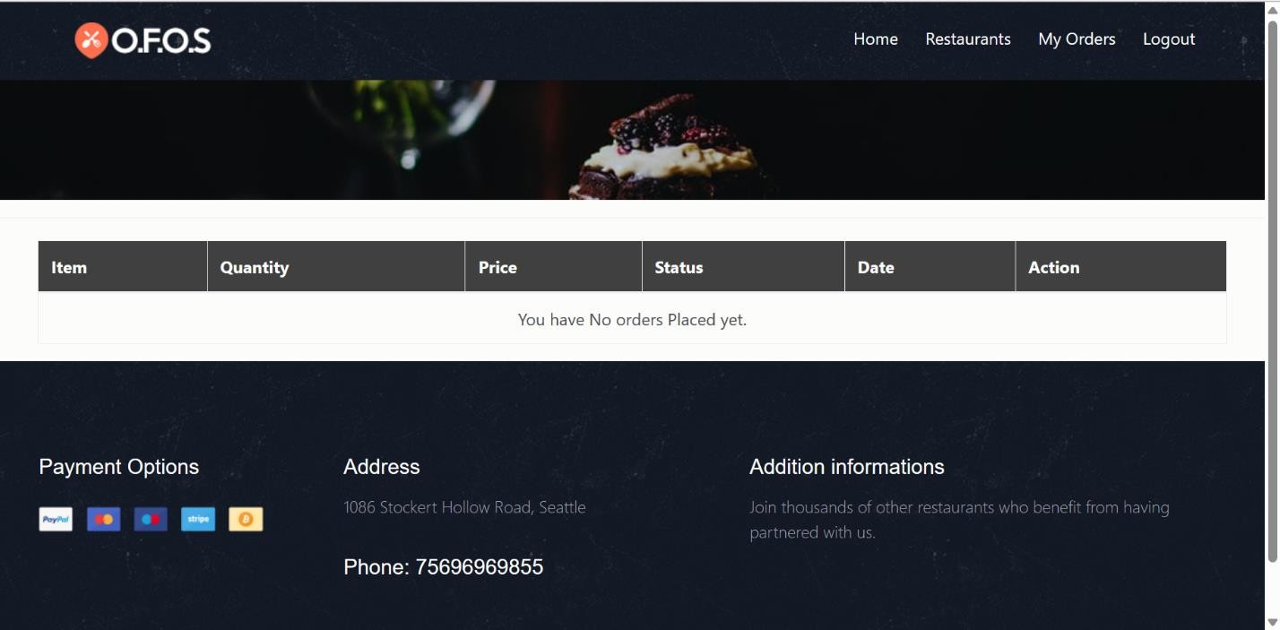

# My Orders Module

* 1. ‘O.F.O.S’ logo should be present on the top left corner of the page.
  2. ‘Home’ link should be present on the top right corner of the page.
  3. ‘Restaurants’ link should be present next to ‘Home’ link.
  4. ‘My orders’ link should be present next to ‘Restaurants’ link.
  5. ‘Logout’ link should be present next to ‘My orders’ link.
  6. In the middle of the page **Item column, Quantity column, Price column, Status column, Date column, Action column** should be present, if there are no orders placed, a tagline should be displayed stating ‘You have No orders Placed yet.’
  7. When user scrolls down, on the left corner ‘Payment options’ label with PayPal, MasterCard, visa, stripe, bitcoin logo should be present below the text.
  8. ‘Address’ label should be present with the tagline ‘1086 Stockert Hollow Road, Seattle’ and ‘Phone:75696969855’ text should be present below the tagline.
  9. ‘Addition informations’ label should be present beside ‘Address’ text and with a tagline ‘Join thousands of other restaurants who benefit from having partnered with us.’

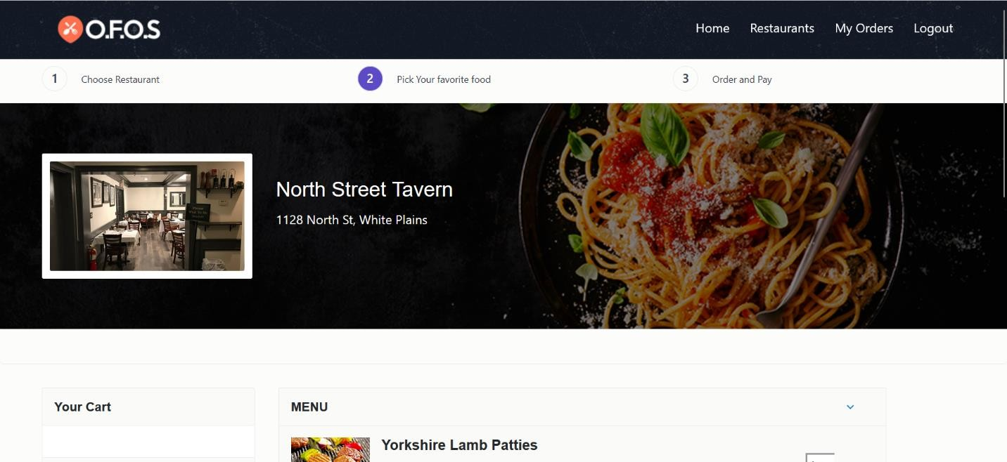

# Restaurant page

* 1. When user click on any dish on the home page respective ‘Restaurant page’ should be displayed with logo, Home, Restaurants, My orders, Logout link respectively.
  2. ‘1.Choose Restaurant’ and ‘2. Pick your ‘favorite food’ , ‘3. Order and Pay’ options should be present.
  3. If user selects ‘Yorkshire Lamb Patties’ from home page then **‘North Street Tavern’** restaurant name and other restaurants like

**‘Eataly’,’Highlands Bar and Grills’, ‘New Ruchi’** with tagline and related image should be displayed.

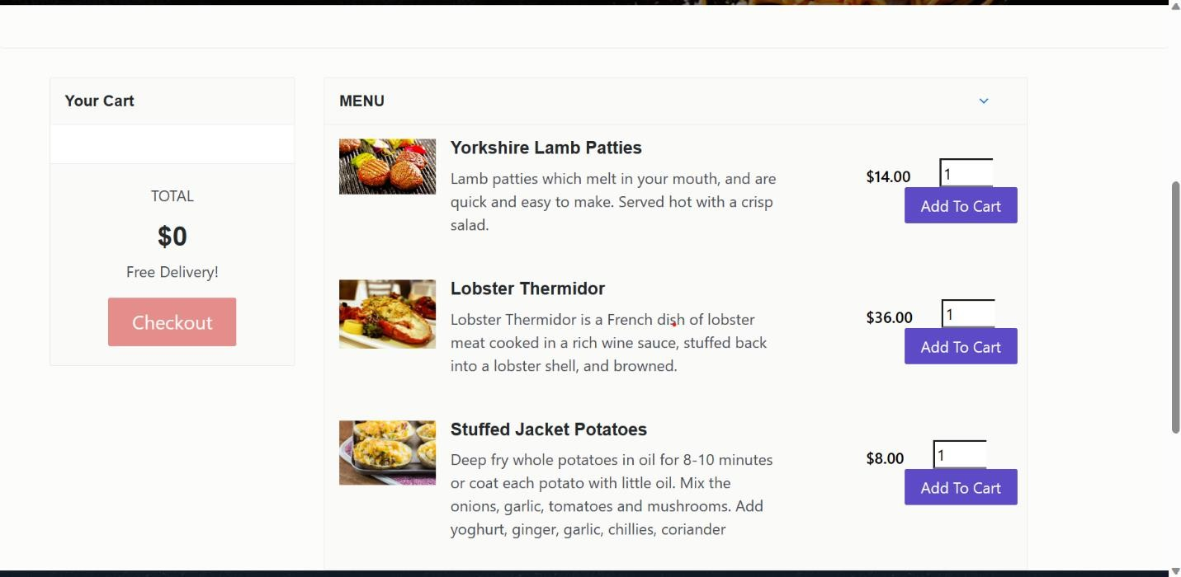

* 1. When user scrolls down then on the left corner of the page ‘Your Cart’ Label should be present.
  2. Below **‘Your Cart’ label** a ‘non-editable text field’ should be present.
  3. **‘Total’ label** should be present in middle below the ‘non-editable text field’.
  4. **‘$0’ symbol** with value should be present in highlighted text.
  5. **‘Free Delivery!’ label** should be present below the ‘$0’ symbol.
  6. **‘Checkout’ button** should be present below the ‘Free Delivery!’ label.
  7. Beside ‘Your cart’ label, **‘Menu’ label** should be present.
  8. **‘Yorkshire Lamb Patties’ label** with food description and related image should be present and beside it cost of the dish in $14.00 and non-editable text-field and below that **‘Add To Cart’ button** should be present.
  9. Same details as ‘Yorkshire Lamb Patties’ should go with other dishes like ‘Lobster Thermidor’ and ‘Stuffed Jacket Potatoes’

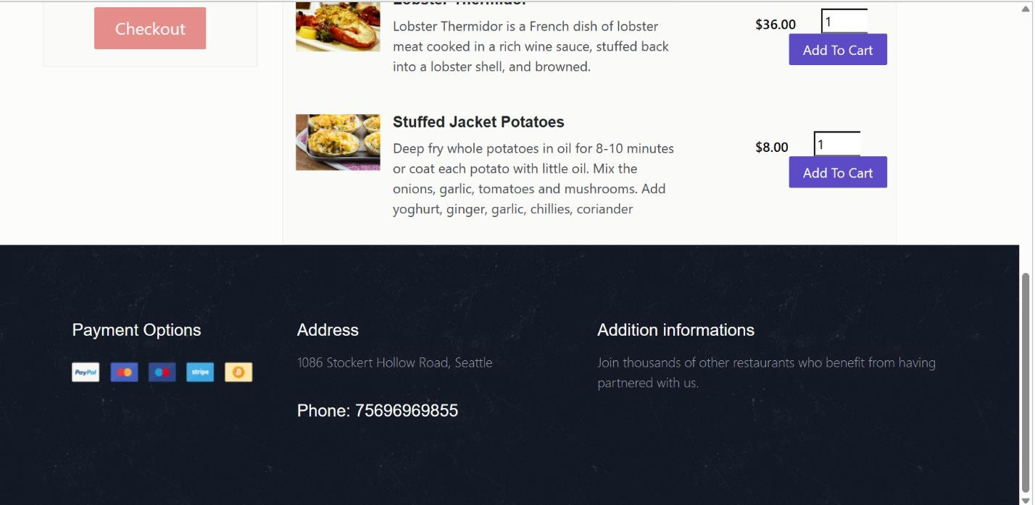

* 1. When user scrolls down, on the left corner ‘Payment options’ label with PayPal, MasterCard, visa, stripe, bitcoin logo should be present below the text.
  2. ‘Address’ label should be present with the tagline ‘1086 Stockert Hollow Road, Seattle’ and ‘Phone:75696969855’ text should be present below the tagline.
  3. ‘Addition informations’ label should be present beside ‘Address’ label and with a tagline ‘Join thousands of other restaurants who benefit from having partnered with us.’

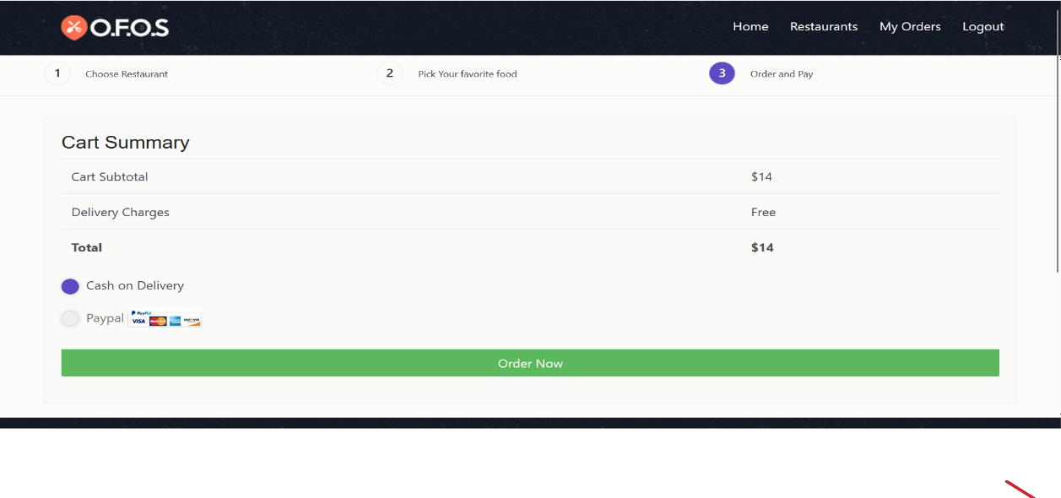

# Cart Summary

* 1. When user click on ‘Checkout’ button he should be able to see this page with ‘O.F.O.S’ logo should be present on the top left corner of the page.
  2. ‘Home’ link should be present on the top right corner of the page.
  3. ‘Restaurants’ link should be present next to ‘Home’ link.
  4. ‘My orders’ link should be present next to ‘Restaurants’ link.
  5. ‘Logout’ link should be present next to ‘My orders’ link.
  6. ‘1.Choose Restaurant’ and ‘2. Pick your favourite food’ , ‘3. Order and Pay’ options should be present.
  7. **‘Cart Summary’ label** should be present on the left corner of the page below ‘Choose Restaurants’.
  8. **‘Cart Subtotal’ label** should be present and beside this value stating ‘$14’ should be present under ‘Cart Summary’ label.
  9. **‘Delivery Charges’ label** should be present and beside it ‘Free’ should be mentioned under ‘Cart Subtotal’ label.

# ‘Total’ label

should be present in bold letters under ‘Delivery Charges’ label beside it ‘$14’ should be present.

# ‘Cash on delivery’

**radio button** should be present with blue color prefilled on that button.

# ‘PayPal’ radio

**button** should be present

# ‘Order Now’

**button** should be present at the end of the page with green color background.

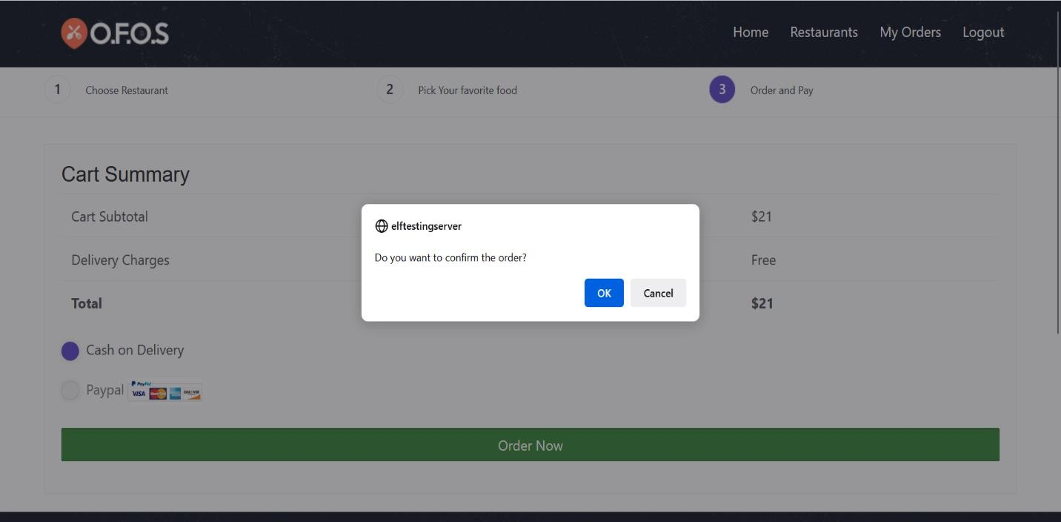

* 1. When user clicks on ‘Order Now’ button he should be able to see a confirmation popup stating **‘Do you want to confirm the order?’** with ‘OK button’ and ‘Cancel button.’

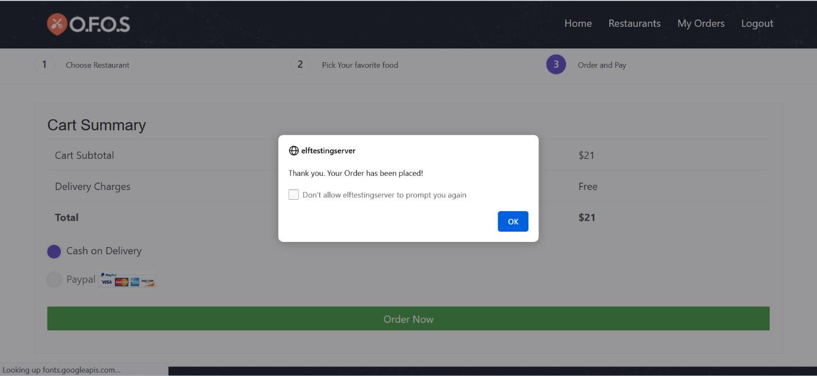

* 1. When user clicks on ‘OK button’ he should be able to see a pop up stating **‘Thank you. Your Order has been placed!’** with a checkbox stating **‘Don’t allow elftestingserver to prompt you again’** with ‘OK button’.

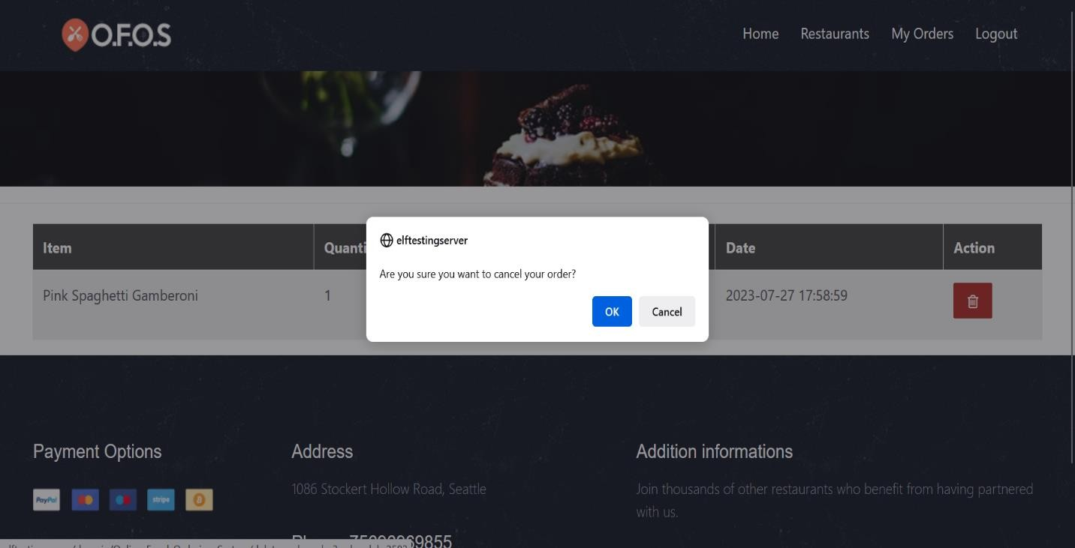

* 1. When user click on ‘delete icon’ a pop-up should appear stating **‘Are you sure you want to cancel your order?’** with ‘OK’ button and ‘Cancel’ button.